SIMATS ENGINEERING
ASSESSMENT TOOL 1

COURSE NAME: Database Management Systems
COURSE CODE: CSA0509

COURSE OUTCOME COVERED

CO1: Analyze DBMS architecture, different data models, schema types, and design ER/EER diagrams, relational schemas for case-based scenarios by identifying entities and relationships. (BL1, BL2)

Activity Tool : Short Answer Text(High)
Assessment Tool Weightage: 40%

QUESTIONS
Q. No | Question | Bloom's Level
1 | Explain schema and instance with examples. Distinguish between logical schema, physical schema, and view schema. | BL1 – Remember
2 | Identify the entities, attributes, and relationships for a Bank Management System and construct its ER diagram. | BL2 – Understand
3 | Explain the Extended ER (EER) model. Describe the concepts of generalization, specialization, and aggregation. | BL2 – Understand
4 | Design an EER diagram for a Hospital Management System incorporating inheritance and weak entities. | BL2 – Understand
5 | Explain the role of a DBA (Database Administrator) and the responsibilities associated with the position. | BL1 – Remember

Code of Conduct:

I ________Lokesh S (192511037)______(Name / Reg No) certify that this submission is my original work and that I have adhered to the guidelines specified for this assessment.
I understand that any violation of academic integrity rules will result in disciplinary action.

Signature of the student:

RUBRICS FOR CALCULATION:

Criteria | Weightage | Level 4 (Exemplary) | Level 3 (Proficient) | Level 2 (Developing) | Level 1 (Beginning)
Concept Identification | 30% | Demonstrates  clear and  complete  understanding of  the concept | Good  understanding  with minor  gaps | Basic  understanding  with some  misconceptions | Poor or  incorrect  understandin  g
Linkages | 25% | Completely  correct answer  with no errors | Mostly correct  with minor  errors | Partially correct  with noticeable  errors | Incorrect or  irrelevant  answer
Organization | 20% | Correctly applies  concepts to solve  the  question/problem | Applies  concepts with  minor  mistakes | Limited or  partially correct  application | No or  incorrect  application
Integration of Literature | 15% | Covers all  required parts of  the question | Covers most  parts with  minor  omissions | Covers only  some parts | Incomplete  or missing  response
Clarity | 10% | Clear, concise,  and well-  organized answer | Understandabl  e with minor  issues | Somewhat  unclear or poorly  structured | Difficult to  understand

1. Explain schema and instance with examples. Distinguish between logical schema, physical schema, and view schema.

Schema
A schema is the overall structure or blueprint of a database. It defines the tables, attributes, relationships, and constraints. It changes very rarely.
Example:
Student table schema:
Student ID | Name | Department | Age

this structure (column names and data types) is the schema.

Instance
An instance is the actual data stored in the database at a particular moment. It changes frequently as records are inserted, updated, or deleted.
Example:
Student_ID | Name | Department | Age
101 | Rahul | CSE | 20
102 | Priya | ECE | 19
These records are the database instance.

Differences

Schema | Instance
Blueprint of the database | Actual data in the database
Changes rarely | Changes frequently
Defines structure | Contains values
Also called database design | Also called database state

Distinguish between Logical Schema, Physical Schema, and View Schema
Logical Schema | Physical Schema | View Schema
Describes the overall logical structure of the database. | Describes how data is physically stored on disk. | Describes only the part of the database seen by a specific user.
Includes tables, attributes, relationships, and constraints. | Includes storage methods, indexes, file organization, and access paths. | Includes selected rows and columns required by a user.
Used by database designers. | Used by DBAs and system administrators. | Used by end users and applications.
Independent of physical storage. | Dependent on storage details. | Independent of physical storage and hides unnecessary data.

2.Identify the entities, attributes, and relationships for a Bank Management System and construct its ER diagram.

Bank Management System – ER Model
1. Entities and Attributes
1. Customer
- Customer_ID (Primary Key)
- Name
- Address
- Phone
- Email
- Date_of_Birth
2. Account
- Account_No (Primary Key)
- Account_Type
- Balance
- Opening_Date
3. Branch
- Branch_ID (Primary Key)
- Branch_Name
- Location
- IFSC_Code
4. Employee
- Employee_ID (Primary Key)
- Name
- Designation
- Salary
- Phone
5. Loan
- Loan_ID (Primary Key)
- Loan_Type
- Loan_Amount
- Interest_Rate
6. Transaction
- Transaction_ID (Primary Key)
- Date
- Type (Credit/Debit)
- Amount

2. Relationships
- Customer → Owns → Account (One customer can own many accounts)
- Branch → Maintains → Account (One branch maintains many accounts)
- Branch → Employs → Employee (One branch has many employees)
- Customer → Takes → Loan (One customer can take multiple loans)
- Account → Records → Transaction (One account has many transactions)

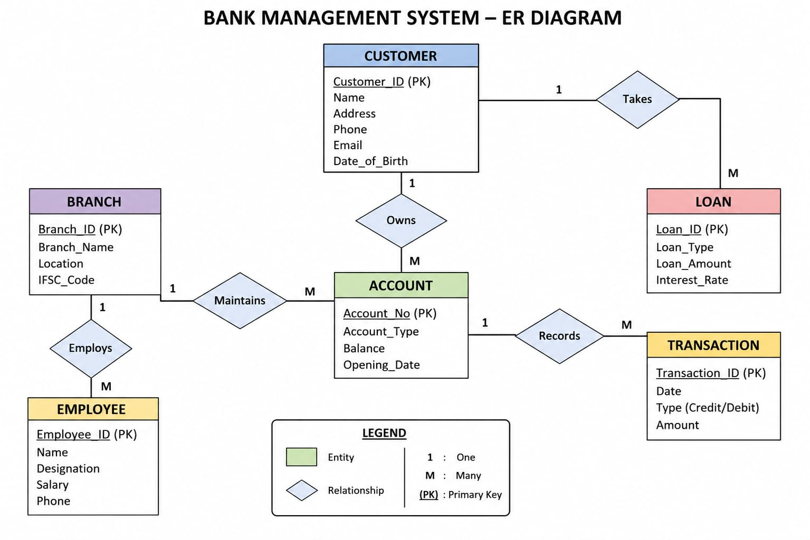

3. Explain the Extended ER (EER) model. Describe the concepts of generalization, specialization, and aggregation.

Extended ER (EER) Model
The Extended Entity-Relationship (EER) Model is an enhanced version of the ER model. It provides additional concepts such as generalization, specialization, and aggregation to represent complex real-world relationships more accurately.
Features of the EER Model
- Supports inheritance between entities.
- Represents superclass and subclass relationships.
- Models complex relationships.
- Improves database design and reduces redundancy.

1. Generalization
Definition:
Generalization is the process of combining two or more lower-level entities with common features into a higher-level entity called a superclass.
Example:
PERSON
/ \
STUDENT EMPLOYEE

- Superclass: Person
- Subclasses: Student, Employee
Explanation:
Both Student and Employee share common attributes like Name, Age, and Address, so they are generalized into the superclass Person.

2. Specialization
Definition:
Specialization is the process of dividing a higher-level entity (superclass) into lower-level entities (subclasses) based on specific characteristics.
Example:

EMPLOYEE
/ \
MANAGER CLERK

- Superclass: Employee
- Subclasses: Manager, Clerk
Explanation:
All employees have common attributes, but Managers and Clerks have additional specific attributes. Therefore, Employee is specialized into Manager and Clerk.

3. Aggregation
Definition:
Aggregation is a technique used to represent a relationship set as a higher-level entity so that it can participate in another relationship.
Example:

EMPLOYEE ---- Works_On ---- PROJECT
|
Aggregation
|
DEPARTMENT
Manages

Explanation:
The Works_On relationship between Employee and Project is treated as a single entity so that Department can manage it.

Difference Between Generalization and Specialization

Generalization | Specialization
Bottom-up approach | Top-down approach
Combines entities into a superclass | Divides a superclass into subclasses
Reduces redundancy | Adds detailed classification
Example: Student + Employee → Person | Example: Employee → Manager, Clerk

Advantages of the EER Model
- Represents complex real-world data.
- Supports inheritance of attributes.
- Reduces data redundancy.
- Improves database organization.
- Makes database design more flexible and easier to maintain.

4.Design an EER diagram for a Hospital Management System incorporating inheritance and weak entities.

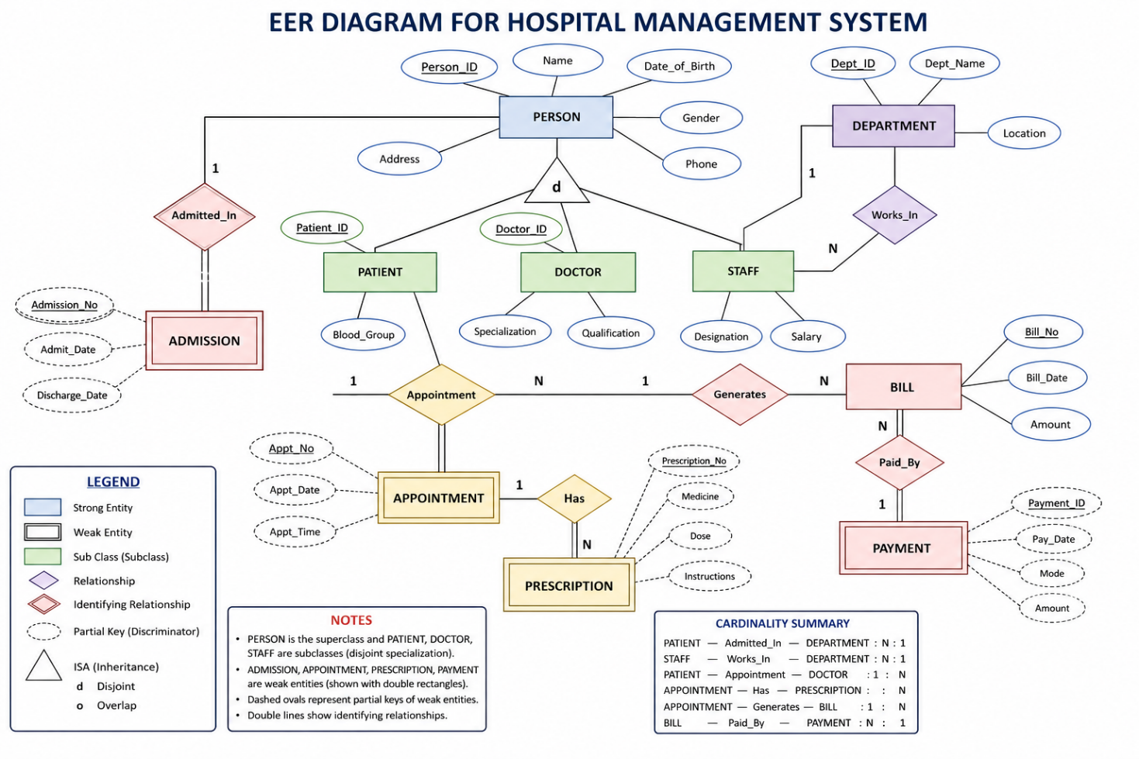

5.Explain the role of a DBA (Database Administrator) and the responsibilities associated with the position.

Role of a Database Administrator (DBA)
A Database Administrator (DBA) is a person responsible for managing, maintaining, securing, and controlling the database management system (DBMS). The DBA ensures that the database operates efficiently, securely, and is always available to users.

Responsibilities of a DBA

1. Database Design
- Designs the database structure.
- Creates tables, relationships, indexes, and constraints.
2. Database Installation and Configuration
- Installs the DBMS software.
- Configures database settings for optimal performance.
3. Security Management
- Creates user accounts and passwords.
- Grants and revokes user privileges.
- Protects the database from unauthorized access.
4. Backup and Recovery
- Performs regular database backups.
- Restores the database in case of system failure or data loss.
5. Performance Monitoring and Tuning
- Monitors database performance.
- Optimizes queries and indexing.
- Improves response time and storage efficiency.
6. Data Integrity
- Ensures data is accurate and consistent.
- Enforces constraints and validation rules.
7. Storage Management
- Allocates and manages storage space.
- Monitors disk usage and memory allocation.
8. Database Maintenance
- Updates the database software.
- Fixes bugs and applies security patches.
- Removes unnecessary or outdated data.
9. Concurrency Control
- Manages multiple users accessing the database simultaneously.
- Prevents conflicts and maintains consistency.
10. Disaster Recovery
- Develops recovery plans for hardware failures or disasters.
- Ensures business continuity through recovery procedures.

